Graphs to Know
You should know the shapes of the following types of graphs and be able to plot at least 2 points on these graphs without the use of a calculator.
Linear  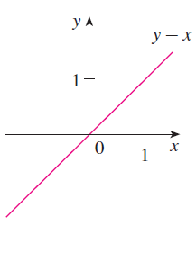 | Quadratic  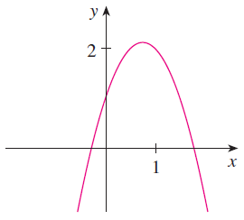  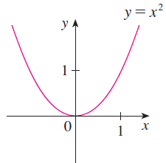
Cubic  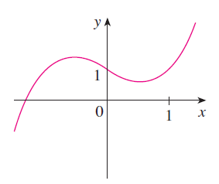  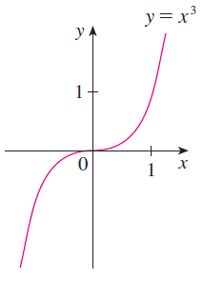 | 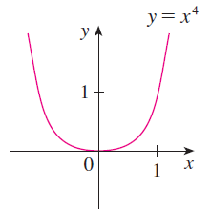  Quartic  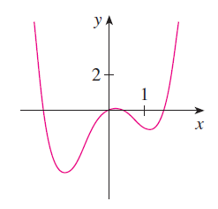
Square root $y=\sqrt{x}$  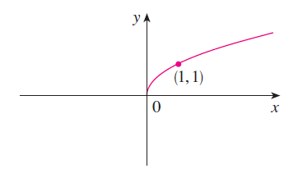 | 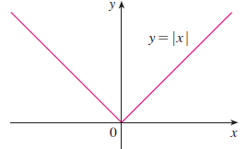  Absolute value $y=\left|x\right|$
Exponential $y=e^{x}$  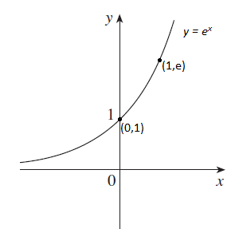 | 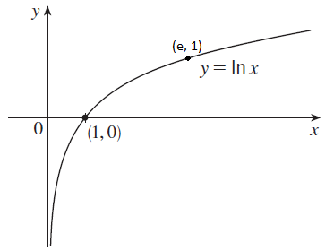  Logarithmic $y=\ln\left(x\right)$
Sine $y=\sin\left(x\right)$  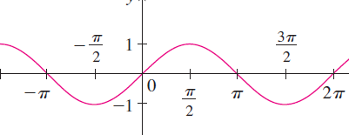 | 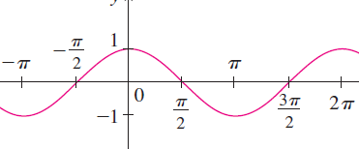  Cosine $y=\cos\left(x\right)$
Tangent $y=\tan\left(x\right)$  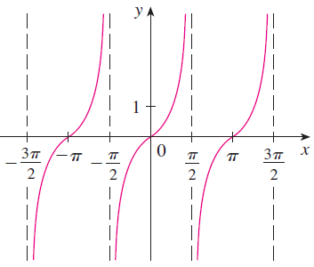  Inverse Tangent $y=tan^{-1}\left(x\right)$  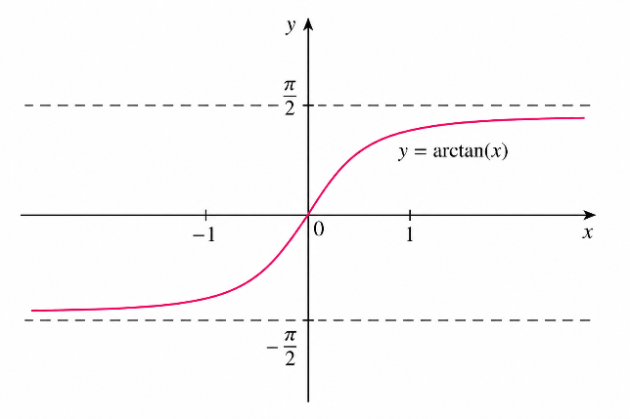 | 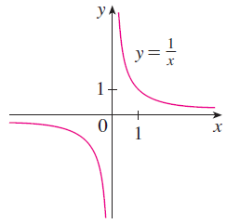  Simple Rational $y=\frac{1}{x}$

